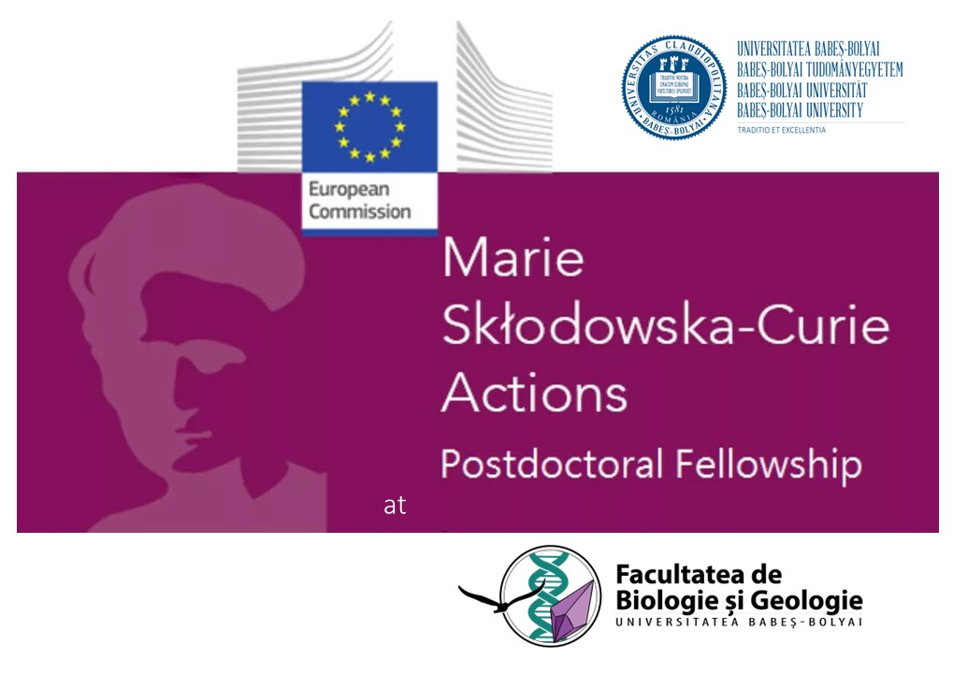
If you are passionate PhD researcher in the area of environmental and aquatic ecology (limnology, cave and groundwater ecology) sciences and you are looking for an opportunity to advance you research career, consider to apply for the Marie Sklodowska – Curie Action Postdoctoral Fellowships (MSCA-PF) at Department of Taxonomy and Ecology of the Faculty of Biology and Geology (FGB), Babes Bolyai University (UBB), Cluj Napoca, Romania!

Deadline: 11 September 2024

By applying for an MSCA-PF in FGB you are applying for two funding opportunities:

- Postdoctoral Fellowships to support researchers’ careers and foster excellence in research. The Postdoctoral Fellowships action targets researchers holding a PhD who wish to carry out their research activities abroad, acquire new skills and develop their careers. PFs help researchers gain experience in other countries, disciplines and non-academic sectors (https://marie-sklodowska-curie-actions.ec.europa.eu/actions/postdoctoral-fellowships)

- ERA Fellowship action. If an application exceeds the quality threshold, but is not funded in the MSCA selection process, it will be eligible for the ERA Fellowship call (without further application, just a tick in the application form). The ERA fellowships support the widening countries (that includes Romania) to balance the mobility flows of researchers.

Researchers interested in PFs

- Should have a PhD degree at the time of the deadline for applications. Applicants who have successfully defended their doctoral thesis but who have not yet formally been awarded the doctoral degree will also be considered eligible to apply

- Must have a maximum of eight years experience in research, from the date of the award of their PhD degree, years of experience outside research and career breaks will not count towards the above maximum, nor will years of experience in research in third countries, for nationals or long-term residents of EU Member States or Horizon Europe Associated Countries who wish to reintegrate to Europe

- Should comply with mobility rules: they must not have resided or carried out their main activity (work, studies, etc.) in the country of the beneficiary (for European Postdoctoral Fellowships), or the host organisation for the outgoing phase (for Global Postdoctoral Fellowships) for more than 12 months in the 36 months immediately before the call deadline.

Why the Department of Taxonomy and Ecology of the Faculty of Biology and Geology?

The Department of Taxonomy and Ecology of FGB has the mission of developing national and international research of excellence. The Department’s professoriate maintain a diverse set of research activities, supported by national and international grants. The activities within the department and associated institutions (Centre 3B) afford many opportunities to undergraduate and graduate students for participation in leading edge research.

The Department of Taxonomy and Ecology objectives

Capitalize, mainly, but not exclusively, the existing human and material resources in the research spaces of the FGB, harmonizing them under a common umbrella of scientific research interests in order to attract highly qualified human resources and raising the national and international visibility of researchers and teaching staff from the Faculty of Biology and Geology and the Botanical Garden.

To actively participate in the development of the local community and in the initiation and consolidation of international cooperation by starting projects of regional interest that fall within the areas of taxonomy, ecology and conservation of the National Research-Development Strategy - Innovation (2022-2027), in field of "Life Sciences" of the European Research Council (ERC).

To ensure the strengthening of the bridge between the academic system of education and postgraduate education, which includes the training and specialization of young researchers (master's students, doctoral students) under the supervision of experienced researchers ("senior researchers"), these categories being able to contribute to the growth the quality and applied nature of academic education in the field of Biology and Environmental Science within FGB.

The Department of Taxonomy and Ecology stands out due to its transdisciplinary research character and the promotion of international collaboration of the department researchers from the Faculty of Biology and Geology, the "Alexandru Borza" Botanical Gardens and the associated members.

The Department of Taxonomy and Ecology knowledge and expertise on fundamental and applied research in systematic and taxonomy of plants, invertebrates and vertebrates and terrestrial and aquatic ecology which is a unique asset of the University Babes Bolyai in Romania.

The Department of Taxonomy and Ecology members holds expertise in:

- Botanic and Systematics

  - The ecology of plant communities
  - Landscape ecology

- Terrestrial ecology

  - Biology and conservation of amphibian, reptile, bird and mammal species

- Aquatic ecology
  - Limnology
  - Groundwater ecology
  - Ecotoxicology
  - Biospeleology

- Environment and climate change

  - Biodiversity of plants and animals in Romania and South Eastern Europe
  - Sustainable management of protected areas
  - Identification of natural compounds with applications in industrial biotechnology, food, remedial, cosmetic or pharmaceutical biotechnologies
  - Groundwater ecology and groundwater risk assessment
  - Biospeleology

By choosing The Department of Taxonomy and Ecology you’ll join a thriving and supportive community of international experts, all dedicated to fostering scientific discovery and innovation in environmental and health areas.

How to apply?

Find a supervisor at The Department of Taxonomy and Ecology community by visiting the https://biogeo.ubbcluj.ro/pages/taxonomie/cercetare-2/ or send an message at carmen.bochis@ubbcluj.ro and sanda.iepure@ubbcluj.ro with your CV and project proposal by August 15 2024 and we can help you find a suitable supervisor. The Department of Taxonomy and Ecology and the Faculty of Biology and Geology research offices will provide you with support in your application.

MSCA Work Programme 2023 – 2025

https://marie-sklodowska-curie-actions.ec.europa.eu/about-msca

Guide for Applicants

https://marie-sklodowska-curie-actions.ec.europa.eu/about-msca/msca-guidelines-on-supervision

Get ready to joi nour community!

